[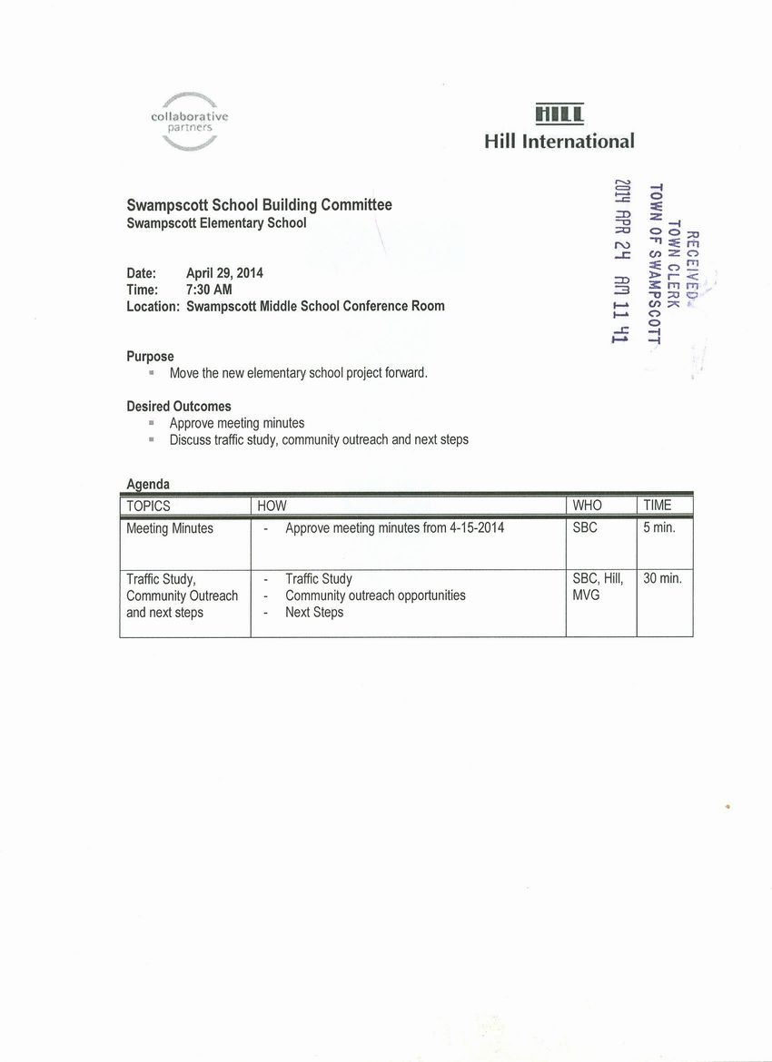](http://www.town.swampscott.ma.us/Public_Documents/SwampscottMA_Calendar/S047B076C-047B07A8.0/School%20Building%20Committee%20April%2029th%20notice%20001.jpg)